GitHub Actions CI Assessment - Submission Evidence
Python Testing and Coverage Workflows
Name | Harsh Mishra
Branch / Section | CS B
Roll No. | 2400290120109
GitHub Username | harsh-mishra123

1. GitHub Repository URL
https://github.com/harsh-mishra123/github-skills-challenge

2. Pull Request URL Used to Validate the Workflows
https://github.com/harsh-mishra123/github-skills-challenge/pull/2
PR #2 "Reenable Fibonacci unit test" was merged into main (merge commit d63a034). The final commit f36487f passed both workflows.

3. Screenshot: GitHub Actions Workflows
Actions tab showing the Python Coverage and Python package workflows. Runs #3 for both workflows (PR #2) completed successfully.
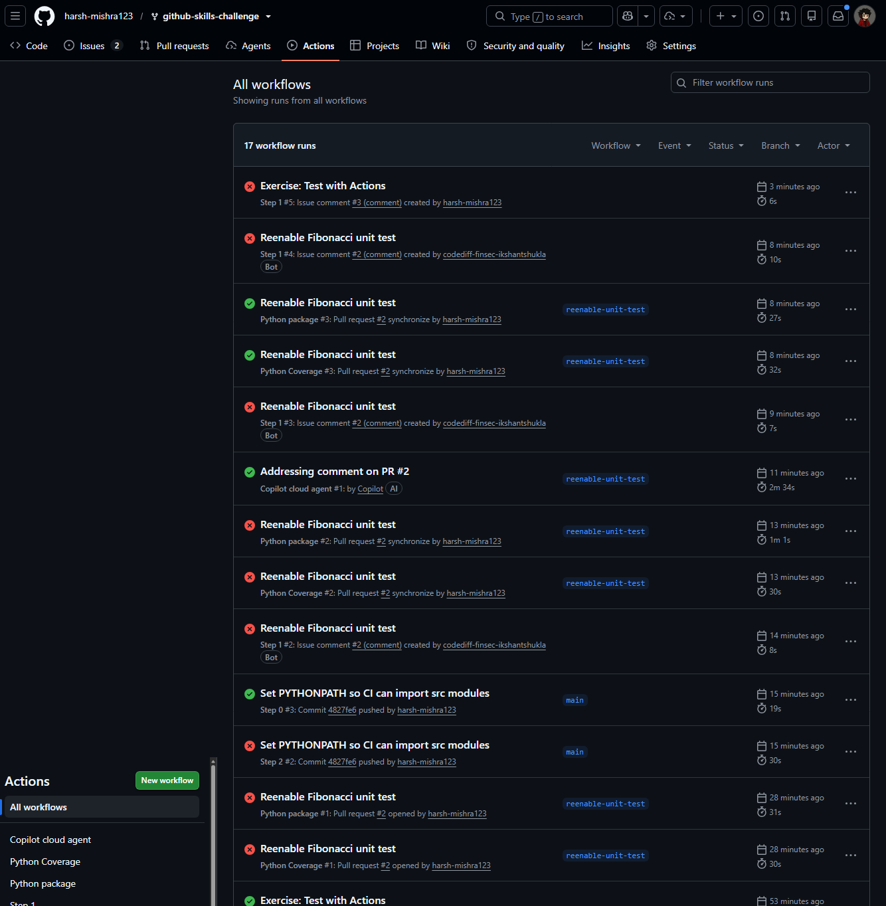

4. Screenshot: Successful Test Workflow Execution
Python package run #3 on PR #2: all three build jobs (Python 3.9, 3.10, 3.11) completed successfully.
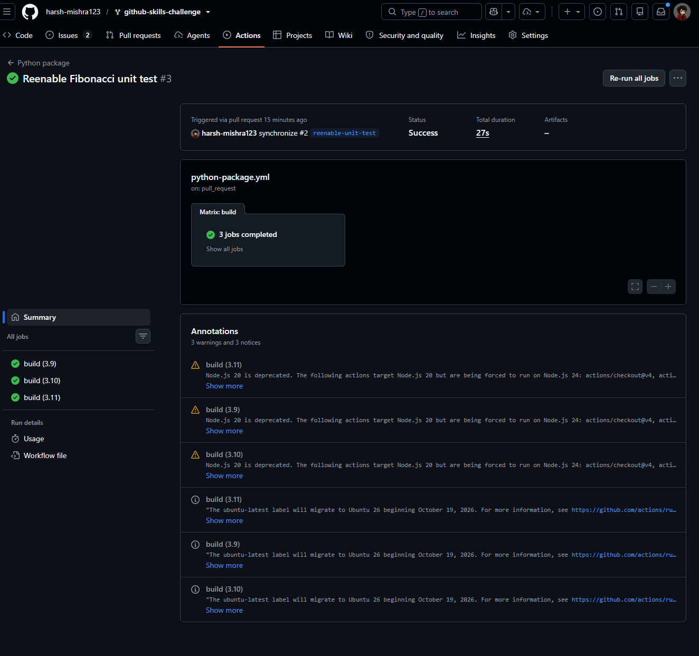

5. Screenshot: Coverage Result / Comment on the Pull Request
Python Coverage run #3 on PR #2: coverage report at 95% (above the 90% minimum). The log shows the action posting the comment to the pull request (HTTP 201 Created).
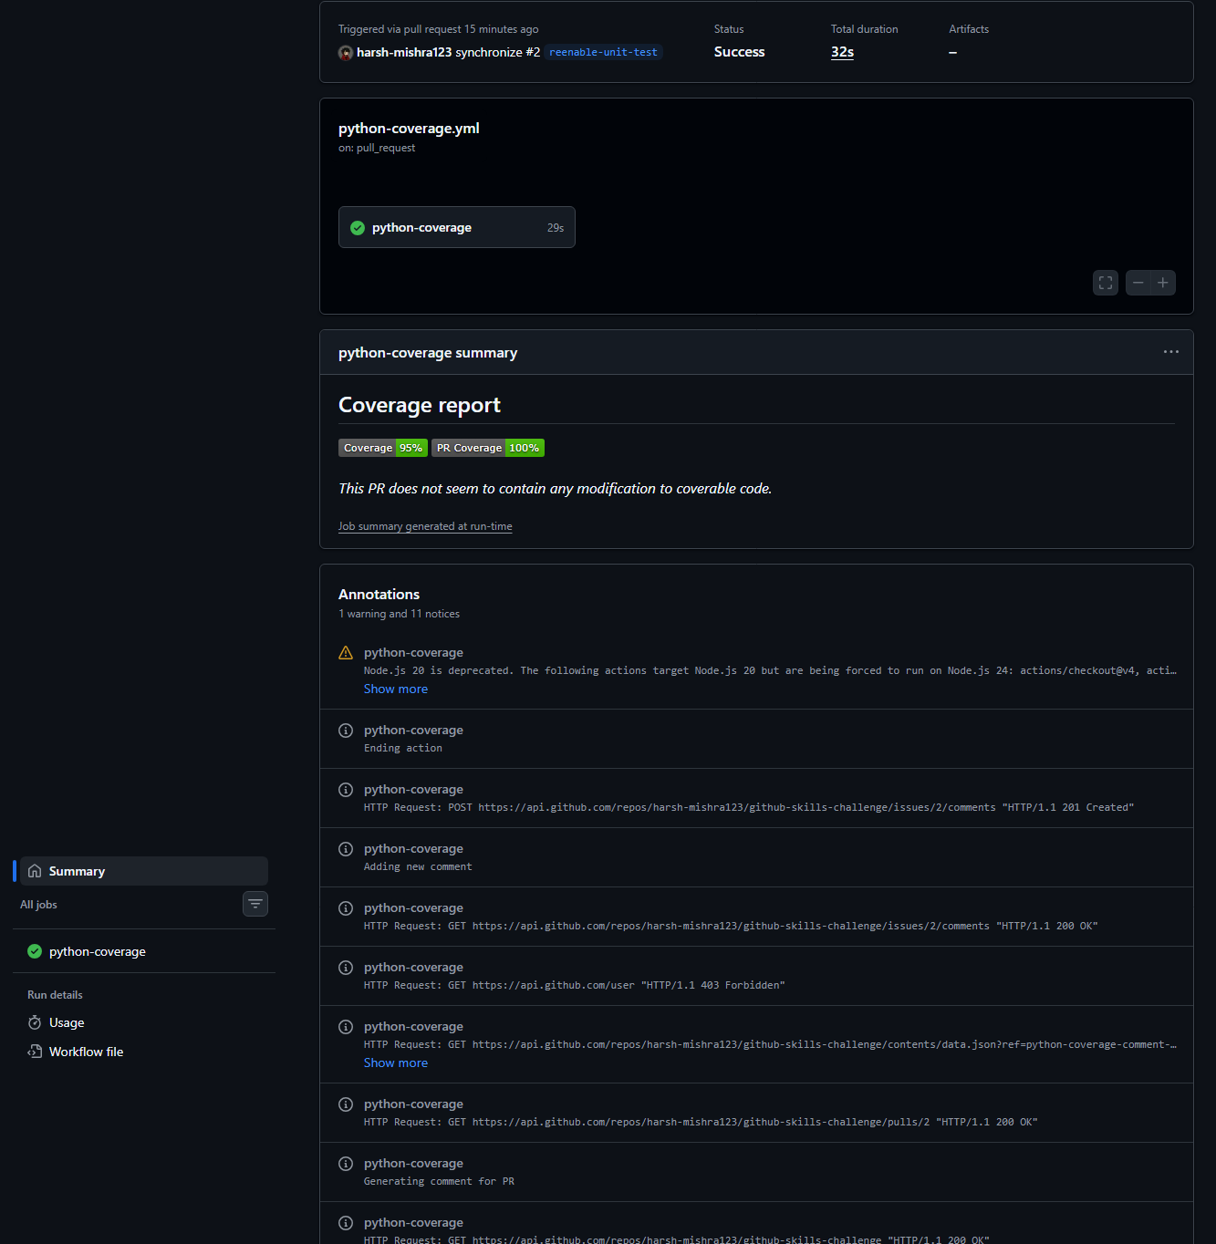

6. Screenshot: Final Repository / Workflow Files
Final workflow files on the main branch: .github/workflows/ contains python-coverage.yml and python-package.yml (python-coverage.yml open in the editor, with PYTHONPATH configured).
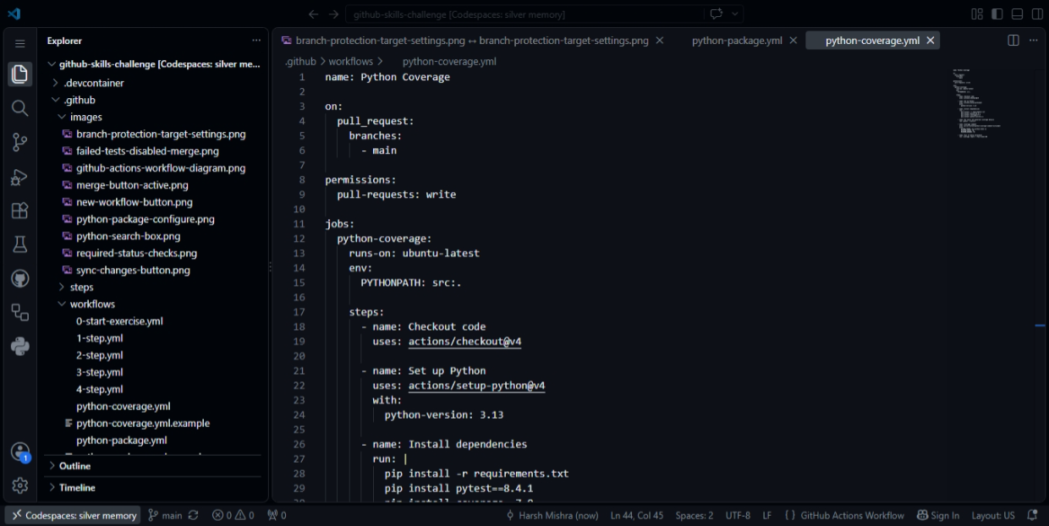

Summary of Implementation
Test workflow (python-package.yml): triggers on pull requests to main, runs on ubuntu-latest across Python 3.9, 3.10 and 3.11, installs dependencies and pytest, and runs pytest --verbose.
Coverage workflow (python-coverage.yml): triggers on pull requests to main with pull-requests: write permission, runs on ubuntu-latest with Python 3.13, runs pytest --cov=src, posts a coverage comment with py-cov-action/python-coverage-comment-action@v3, and fails below 90% coverage.
Fixes made during validation: set PYTHONPATH=src:. so CI can import the src modules; corrected the Fibonacci test expectation from 89 to 55 (the 10th Fibonacci number), as instructed by the exercise; added negative-input tests and a new test file (tests/test_aiops_components.py) to raise real coverage. The application source, existing tests and coverage threshold were not altered to manipulate results.

